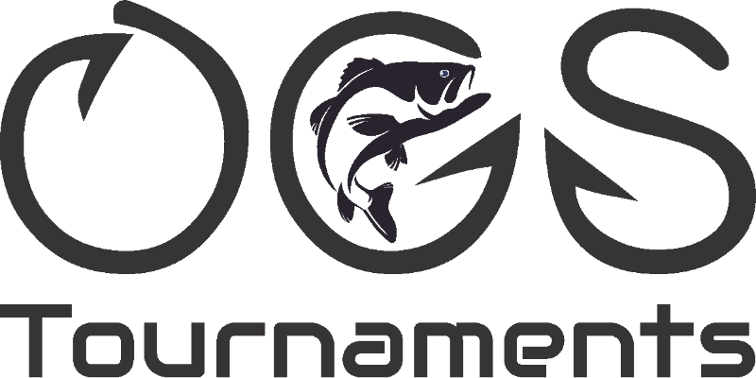

Mike Oglesbee
Wind Creek Bass Trail Classic Championship
Lake Martin, Alabama
Team Tournament Results
May 2nd, 2020

- Daivd Pollard/John Bryan 13.57 (Skeeter)
- Shaye Baker/Ben Weldon 13.05 (Ranger)
- Steve Ingram 11.97 (Ranger)
- Michael Ward/Dalton BoBo 11.59 (Nitro)
- Heath Howell/Time Lawrence 11.43
- Jimmy Miller/Jeremy Miller 11.20
- Josh Lackey/Barrett Jones 11.08
- Felton Langley/Trip Weldon 10.79
- Sydney Reynolds/Travis Reynolds 10.75 (Big Fish 4.70)
- Lanier Butron/Mike Keel 10.65
- Michael Daivs/Mark Cannon 10.58
- Brent Reaves/Peyton Goggins 10.44
- Derrick Hutchins/Roy Hurst 10.17
- Marty Giddens/Steve Fincher 9.96
- Martin Arwood/Doyle Coker 9.49
- Brandon Simmons/Ryan Miller 9.30
- Steve Morgan/Alan Morgan 9.22
- Rodney Cox/George Fuller 9.12
- Tim Kennedy/Rickey Kelley 8.95
- Billy Adamson/Lee Varner 8.91
- Shane Turner/Pat Turner 8.80
- Chris Landers 8.56
- Jim Barrett/GT Smith 8.47
- Mike Autry/Matt Daniel 8.36
- Raymond/Curtis Holman 7.94
- Mark Hankes/Steve Lipham 7.48
- Clay Langford/Chase Bradshaw 6.60
- Scott Cooper/Todd Smith 5.56
- Gregg Baker/Jordan Creel 0.00
- Chris Harper/Charles Lawson 0.00
- Dewayne Jones/Don Belew 0.00
- Rick Rhodes/Aubry Croumbley 0.00
- Dusty Robinson/Walter Hudgins 0.00
- Joel Smith/Cold Adcock 0.00

Big Fish:
Travis Reynolds 4.70
Average Joe:
Marty Giddens/Steve Fincher 9.96
Total Number of Fish Caught: 140
Total Weight: 274.58lbs

